Name : U.Siddhartha

Roll No: 2403A54122

Task-1:

Syntax error:-

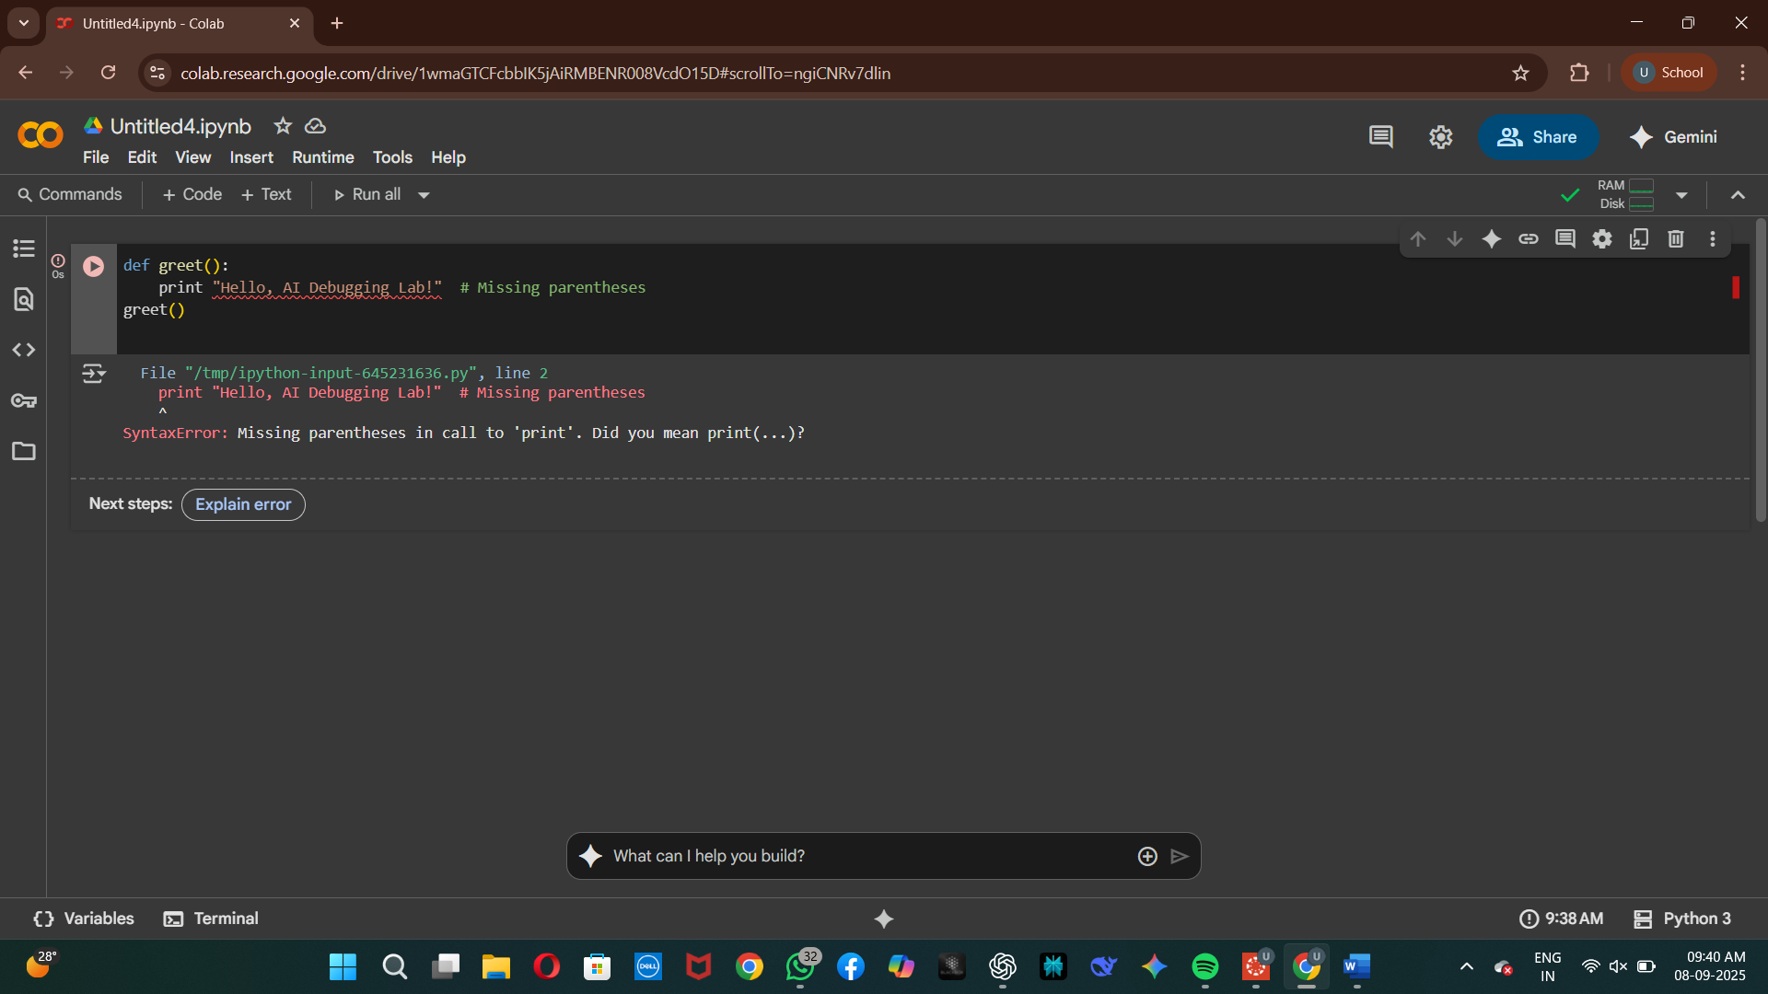

Code without error:-

Task:-2

Logic Error:-

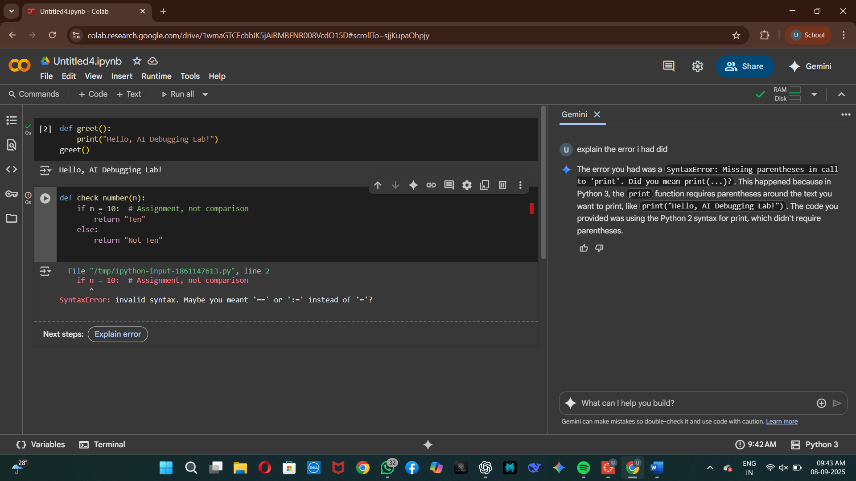

Code without Error:-

Task3:-

Runtime error:-

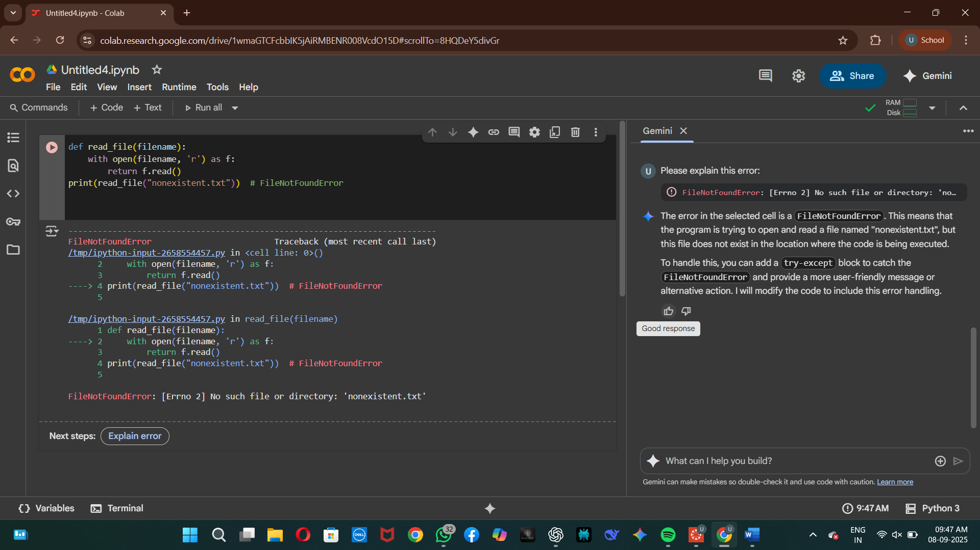

Code Without Error:-

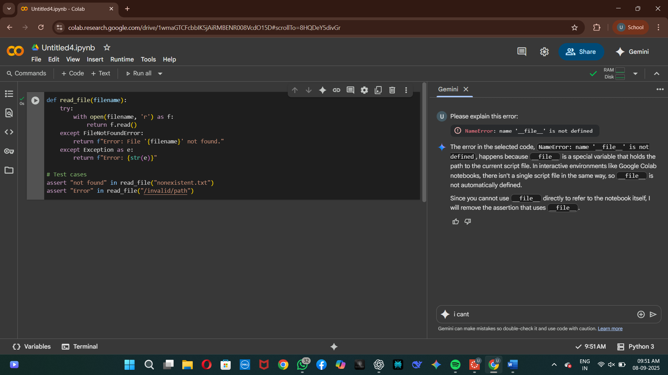

Task 4:-

Attribute Error:-

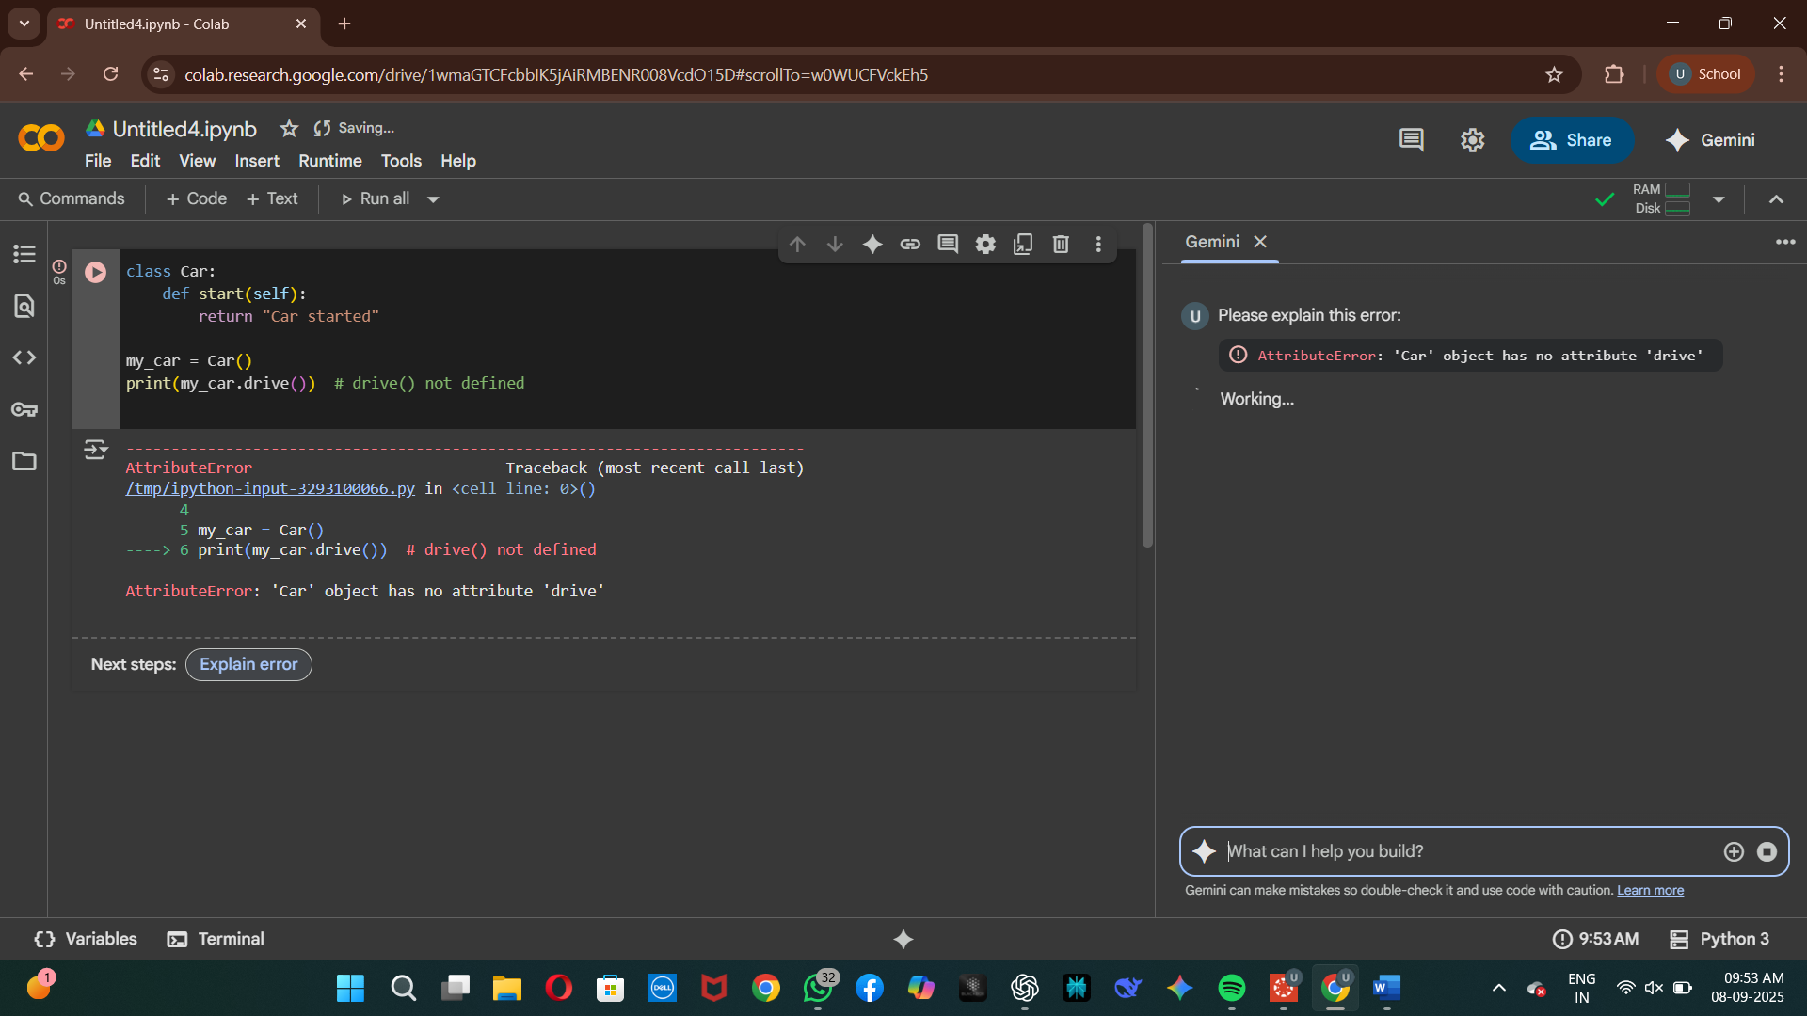

Code Without Error:-

Task 5:-

Type error:-

Code Without Error:-

